* [Making Offers to Customers (Self-Learning)](http://127.0.0.1:54857/help/topic/com.ibm.spss.modeler.tutorial/clementine/example_selflearn.htm)

# Making Offers to Customers (Self-Learning)

The Self-Learning Response Model (SLRM) node generates and enables the updating of a model that allows you to predict which offers are most appropriate for customers and the probability of the offers being accepted. These sorts of models are most beneficial in customer relationship management, such as marketing applications or call centers.

This example is based on a fictional banking company. The marketing department wants to achieve more profitable results in future campaigns by matching the right offer of financial services to each customer. Specifically, the example uses a Self-Learning Response Model to identify the characteristics of customers who are most likely to respond favorably based on previous offers and responses and to promote the best current offer based on the results.

This example uses the stream pm_selflearn.str, which references the data files pm_customer_train1.sav, pm_customer_train2.sav, and pm_customer_train3.sav. These files are available from the Demos folder of any IBM® SPSS® Modeler installation. This can be accessed from the IBM SPSS Modeler program group on the Windows Start menu. The pm_selflearn.str file is in the streams folder.

Existing Data

The company has historical data tracking the offers made to customers in past campaigns, along with the responses to those offers. These data also include demographic and financial information that can be used to predict response rates for different customers.

*Figure 1. Responses to previous offers*

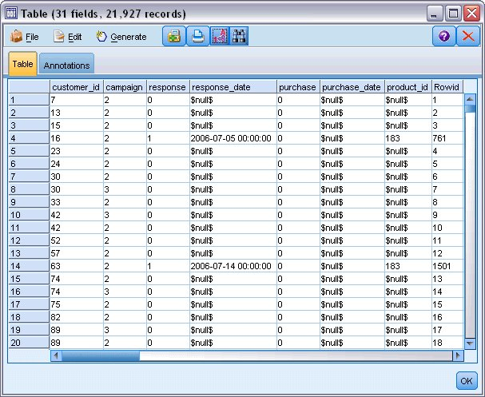

**Building the Stream**

1. Add a Statistics File source node pointing to *pm_customer_train1.sav*, located in the *Demos* folder of your IBM® SPSS® Modeler installation.

*Figure 1. SLRM sample stream*

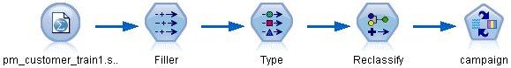

1. Add a Filler node and select campaign as the Fill in field.
2. Select a Replace type of **Always**.
3. In the Replace with text box, enter to_string(campaign) and click **OK**.

*Figure 2. Derive a campaign field*

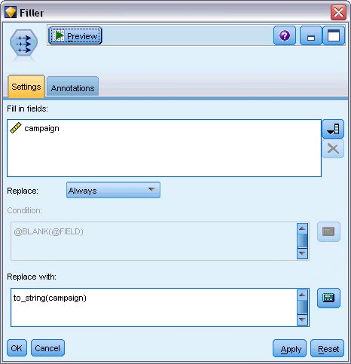

1. Add a Type node, and set the *Role* to **None** for the *customer_id*, *response_date*, *purchase_date*, *product_id*, *Rowid*, and *X_random* fields.

*Figure 3. Changing the Type node settings*

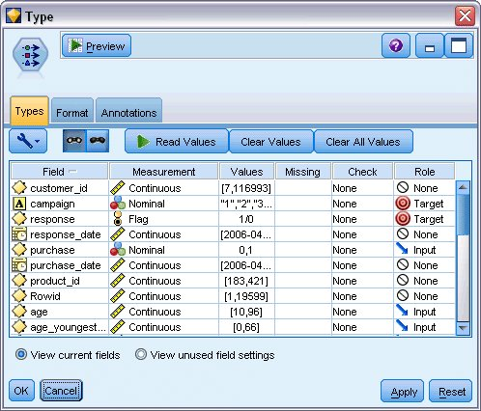

1. Set the *Role* to **Target** for the *campaign* and *response* fields. These are the fields on which you want to base your predictions.

Set the **Measurement** to **Flag** for the *response* field.

1. Click **Read Values**, then **OK**.

Because the campaign field data show as a list of numbers (1, 2, 3, and 4), you can reclassify the fields to have more meaningful titles.

1. Add a Reclassify node to the Type node.
2. In the **Reclassify into** field, select **Existing field**.
3. In the **Reclassify field** list, select **campaign**.
4. Click the **Get** button; the campaign values are added to the *Original value* column.
5. In the *New value* column, enter the following campaign names in the first four rows:
   * **Mortgage**
   * **Car loan**
   * **Savings**
   * **Pension**
6. Click **OK**.

*Figure 4. Reclassify the campaign names*

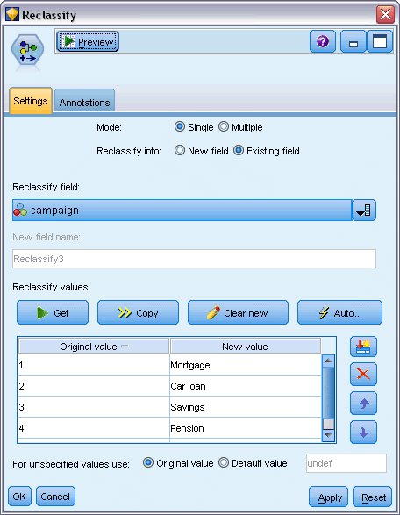

1. Attach an SLRM modeling node to the Reclassify node. On the Fields tab, select **campaign** for the Target field, and **response** for the Target response field.

*Figure 5. Select the target and target response*

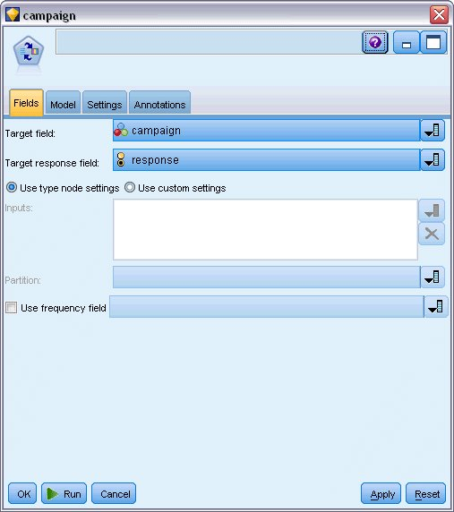

1. On the Settings tab, in the Maximum number of predictions per record field, reduce the number to 2.

This means that for each customer, there will be two offers identified that have the highest probability of being accepted.

1. Ensure that **Take account of model reliability** is selected, and click **Run**.

*Figure 6. SLRM node settings*

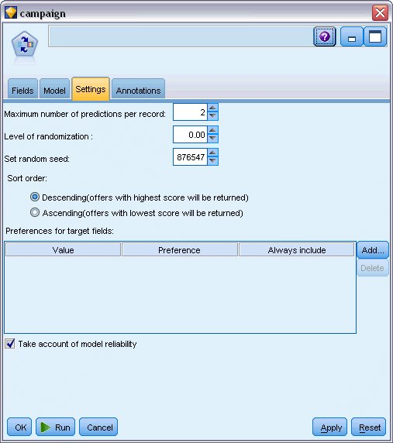

**Browsing the Model**

1. Open the model nugget. The Model tab initially shows the estimated the accuracy of the predictions for each offer and the relative importance of each predictor in estimating the model.

To display the correlation of each predictor with the target variable, choose **Association with Response** from the **View** list in the right-hand pane.

1. To switch between each of the four offers for which there are predictions, select the required offer from the **View** list in the left-hand pane.

*Figure 1. SLRM model nugget*

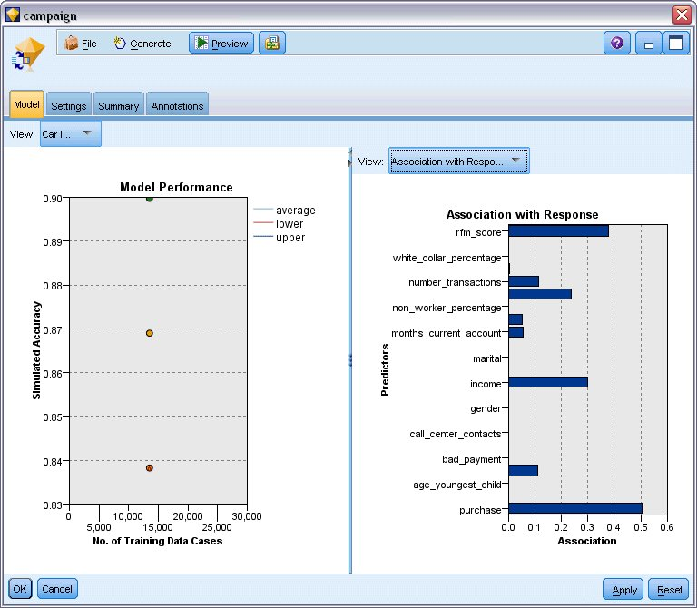

1. Close the model nugget window.
2. On the stream canvas, disconnect the IBM® SPSS® Statistics File source node pointing to *pm_customer_train1.sav*.
3. Add a Statistics File source node pointing to *pm_customer_train2.sav*, located in the *Demos* folder of your IBM SPSS Modeler installation, and connect it to the Filler node.

*Figure 2. Attaching second data source to SLRM stream*

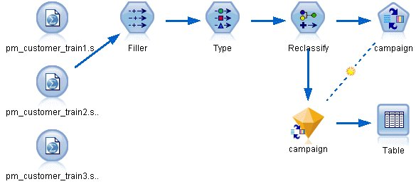

1. On the Model tab of the SLRM node, select **Continue training existing model**.

*Figure 3. Continue training model*

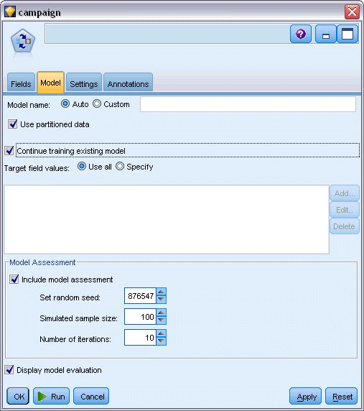

1. Click **Run** to re-create the model nugget. To view its details, double-click the nugget on the canvas.

The Model tab now shows the revised estimates of the accuracy of the predictions for each offer.

1. Add a Statistics File source node pointing to *pm_customer_train3.sav*, located in the *Demos* folder of your IBM SPSS Modeler installation, and connect it to the Filler node.

*Figure 4. Attaching third data source to SLRM stream*

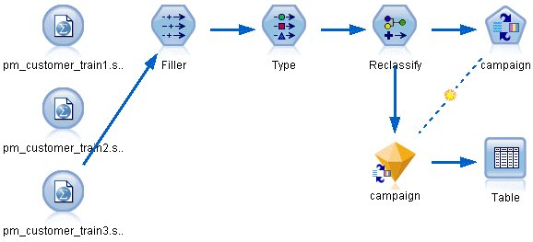

1. Click **Run** to re-create the model nugget once more. To view its details, double-click the nugget on the canvas.
2. The Model tab now shows the final estimated accuracy of the predictions for each offer.

As you can see, the average accuracy fell slightly (from 86.9% to 85.4%) as you added the additional data sources; however, this fluctuation is a minimal amount and may be attributed to slight anomalies within the available data.

*Figure 5. Updated SLRM model nugget*

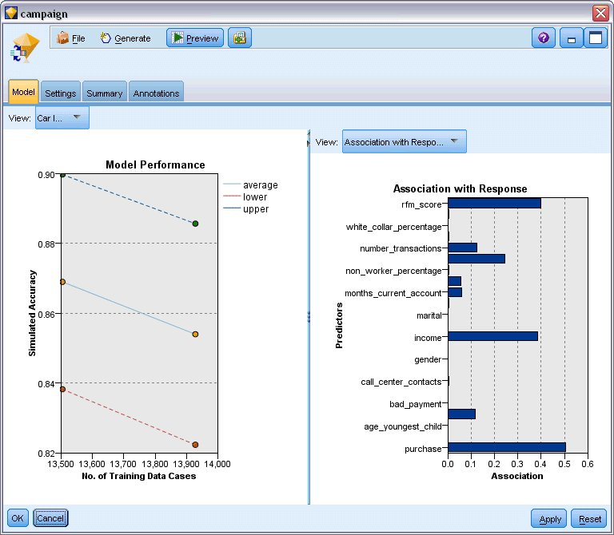

1. Attach a Table node to the last (third) generated model and execute the Table node.
2. Scroll across to the right of the table. The predictions show which offers a customer is most likely to accept and the confidence that they will accept, depending on each customer's details.

For example, in the first line of the table shown, there is only a 13.2% confidence rating (denoted by the value 0.132 in the *$SC-campaign-1* column) ) that a customer who previously took out a car loan will accept a pension if offered one . However, the second and third lines show two more customers who also took out a car loan; in their cases, there is a 95.7% confidence that they, and other customers with similar histories, would open a savings account if offered one, and over 80% confidence that they would accept a pension.

*Figure 6. Model output - predicted offers and confidences*

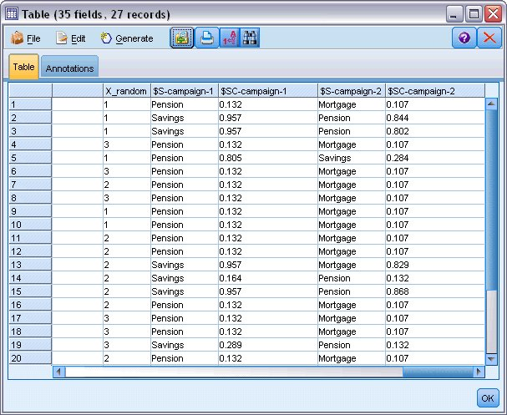

Explanations of the mathematical foundations of the modeling methods used in IBM SPSS Modeler are listed in the *IBM SPSS Modeler Algorithms Guide*, available as a PDF file as part of your product download.

Note also that these results are based on the training data only. To assess how well the model generalizes to other data in the real world, you would use a Partition node to hold out a subset of records for purposes of testing and validation.